The traceroute goes back and forth with MPLS, till ttl expires. Why ?

**Labels: HPE Comware Switch**

**Problem:**

**Here is the the network connectivity:**

MPLS network ip >172.31.4.111 (next hop from 5820 switch)  
|  
|  
|  
5820 switch  
interface vlan 3850(172.31.4.110 )  
interface vlan 410 (172.30.37.241/29)  
|  
|  
|  
Firewall ip > 172.30.37.242  
|  
|  
|  
10.158.100.21  
  
Traffic destined to 10.158.100.121 comes from outside of MPLS , reaches MPLS, hits HPE core switch(5820) and goes back and forth to MPLS, till TTL expires.

**Diagnostics:**

There is a static route with MPLS and there is BGP learnt route to 10.158.100.21 LAN segment.

Because routing limit of the switch was reached, this newly added BGP learnt route(10.158.100.21 LAN segment) was never added to the main routing table.

Below log message could be in seen in HPE Comware 5 switch:

**%Jun 20 04:07:47:828 2000 inpunab-core001 RM/4/RM_ROUTE_REACH_LIMIT: Max active routes 12288 reached in URT of netcore  
  
12288 is the routing limit.**

Note:

**netcore** is the vpn-instance.

Here is the routing-table statistics from the switch:

[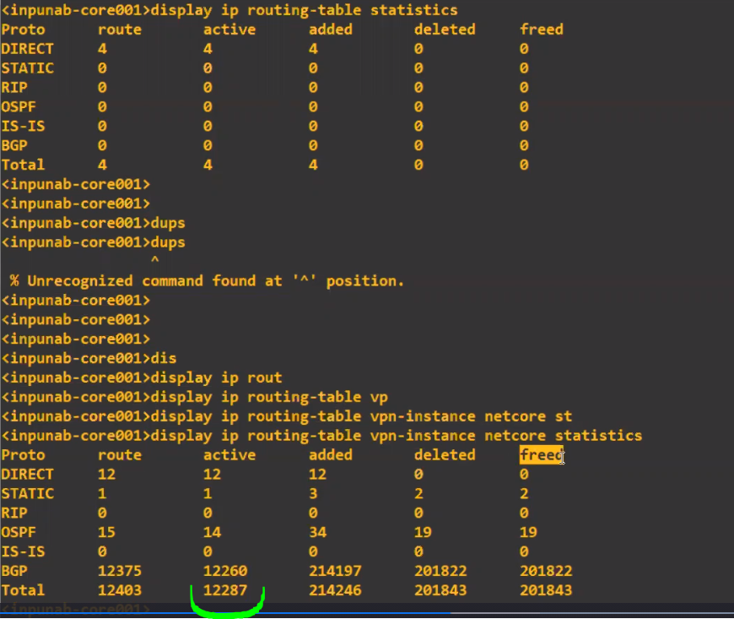](https://akb.arubanetworks.com/media/ckuploads/1110/2021/04/25/limit-reached.PNG)

Here is the max route guide for this old 5820X switch (Comware 5).

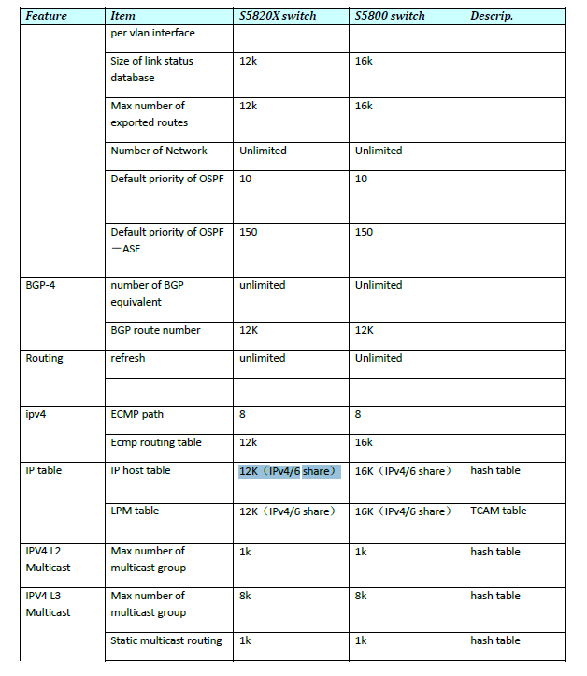

**Solution:**

**To get BGP learnt route(10.158.100.21 LAN segment) in the main routing-table, customer should be advised to keep the number of routes in the routing-table below 12K.**

**Attachments:**

[max routes for 5820x.PNG](https://akb.arubanetworks.com/private/articles/60854f77853cb5c188f97065/attachments/max routes for 5820x.PNG/)

[limit reached.PNG](https://akb.arubanetworks.com/private/articles/60854f77853cb5c188f97065/attachments/limit reached.PNG/)

Tags: HPE Comware Switch, v5.5.5, routing limit